🎵 Rythamic Tunes – Project Documentation

📘 Introduction
Project Title: Rythamic Tunes
Team Members:
1.Salamath nisha – Frontend Developer
2.Sathana– UI/UX Designer
3.subhasri– State Management & Testing
4.Suhaina fathima, surathul majima– Project Lead & Routing Specialist

🎯 Project Overview

Purpose:
Rythamic Tunes is a modern, responsive music streaming frontend application designed to provide users with a seamless experience discovering, playing, and managing their favorite tunes. The aim is to create a fast, aesthetically pleasing, and intuitive UI using React.

Features:
- Responsive homepage with featured tracks and playlists
- Music player with play, pause, skip, and volume control
- Search functionality for artists, songs, and albums
- Dynamic song/album/artist pages
- User playlist creation and management
- Light/Dark theme toggle

🏗 Architecture

Component Structure:
src/
├── components/
│ ├── Header.jsx
│ ├── Footer.jsx
│ ├── MusicPlayer.jsx
│ ├── TrackCard.jsx
│ ├── Sidebar.jsx
├── pages/
│ ├── Home.jsx
│ ├── Search.jsx
│ ├── Playlist.jsx
│ ├── SongDetails.jsx
│ ├── ArtistDetails.jsx
├── context/
│ └── GlobalStateProvider.jsx
├── hooks/
│ └── useFetchSongs.js
├── App.jsx
├── index.js

State Management:
- Global State: Context API with useReducer to manage theme, currently playing track, and user playlists.
- Local State: Managed with useState within individual components like Search, MusicPlayer, and TrackCard.

Routing:
Using react-router-dom v6, routing is structured as follows:
<Routes>
<Route path="/" element={<Home />} />
<Route path="/search" element={<Search />} />
<Route path="/song/:id" element={<SongDetails />} />
<Route path="/artist/:id" element={<ArtistDetails />} />
<Route path="/playlist" element={<Playlist />} />
</Routes>

⚙ Setup Instructions

Prerequisites:
- Node.js (v16+)
- npm or yarn

Installation:
Clone the repository:
git clone https://github.com/your-username/rythamic-tunes.git
cd rythamic-tunes

Install dependencies:
npm install

Configure environment variables:
Create a .env file in the root directory:
REACT_APP_API_KEY=your_api_key_here
REACT_APP_API_URL=https://api.example.com

📁 Folder Structure

Client:
src/
├── assets/ # Images, logos, icons
├── components/ # Reusable UI components
├── pages/ # Page-level components for routing
├── context/ # Global state using Context API
├── hooks/ # Custom React hooks
├── styles/ # Global styles and themes

Utilities:
- useFetchSongs.js – Custom hook for fetching data from the API
- theme.js – Utility for theme toggling
- formatTime.js – Converts seconds to mm:ss format

🚀 Running the Application
To start the application locally:
npm start

This will start the development server at http://localhost:3000.

📦 Component Documentation

Key Components:
- MusicPlayer
  - Props: track, isPlaying, onPlayPause
  - Description: Core player with controls and progress bar
- TrackCard
  - Props: track, onClick
  - Description: Displays a single track with thumbnail, title, and artist
- Sidebar
  - Props: none
  - Description: Contains navigation and theme toggle

Reusable Components:
- Button
  - Accepts variant, onClick, disabled
- Modal
  - Used for displaying playlist actions

📊 State Management

Global State:
Stored in GlobalStateProvider.jsx and accessed via Context:
{
theme: 'light' | 'dark',
currentTrack: {},
isPlaying: false,
playlists: []
}

Local State:
Handled via useState within components like Search for managing query strings or TrackCard for hover states.

🎨 User Interface

Screenshots/GIFs:
Include actual UI screenshots or animated previews here.
- 🎵 Home Page: Featured playlists and trending tracks
- 🔍 Search Page: Real-time results as you type
- 🎧 Player: Fixed at the bottom with responsive controls
- 🌙 Theme Toggle: Light/Dark switch in sidebar

💅 Styling

CSS Frameworks/Libraries:
- Tailwind CSS – For utility-first styling
- Styled-Components – Used minimally for dynamic theming

Theming:
Supports Light and Dark themes via Context API and Tailwind’s dark mode configuration.
const [theme, setTheme] = useState('light');

✅ Testing

Testing Strategy:
- Unit Testing: For utility functions and isolated components using Jest
- Component Testing: UI behavior using React Testing Library
- E2E Testing: Planned for Cypress in future releases

Code Coverage:
- Jest is configured to generate coverage reports:
npm test -- --coverage

📸 Screenshots or Demo
Include URLs or images as appropriate
- Live Demo: rythamic-tunes.netlify.app
- GitHub Repo: github.com/your-username/rythamic-tunes
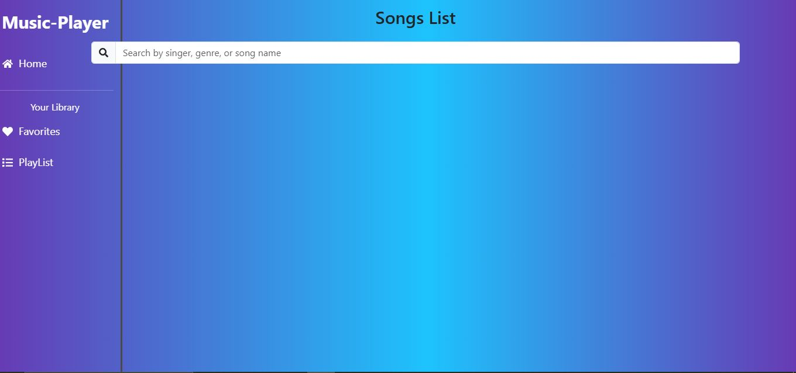

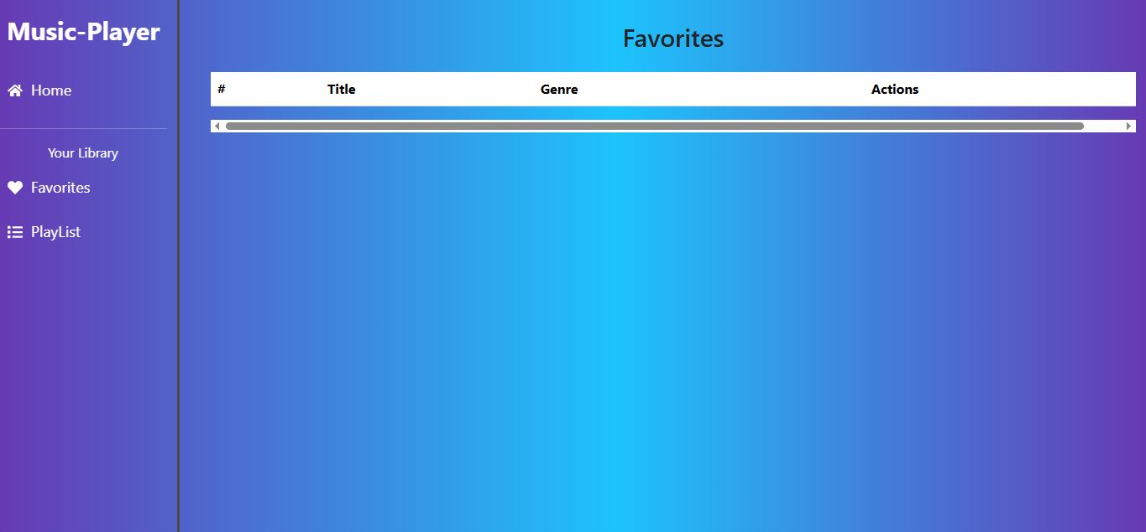

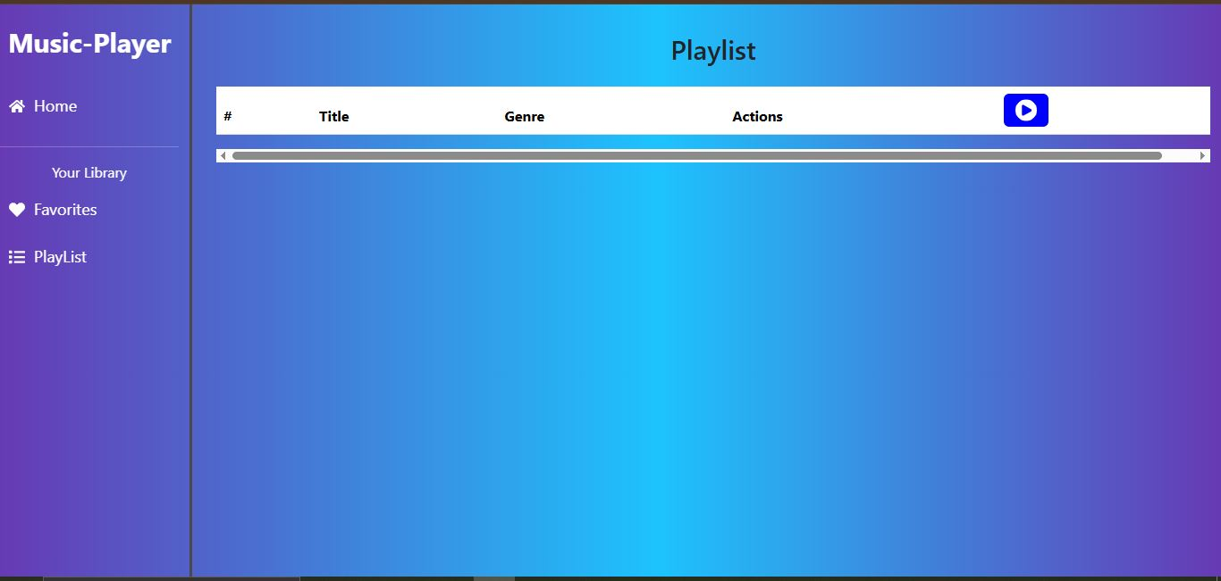

🐞 Known Issues
- Audio player may not pause correctly on mobile Safari
- Search API has rate limits causing occasional fetch failures
- Playlist names are not editable after creation

🚧 Future Enhancements
- 🎤 Voice search for finding tracks
- 🧠 AI-generated playlists based on mood
- 📱 PWA support for offline use
- 🌐 i18n support for multiple languages
- 🎨 Enhanced animations and transitions

Let me know if you'd like this exported as a Markdown file or need help creating visuals/screenshots to go along with it.

